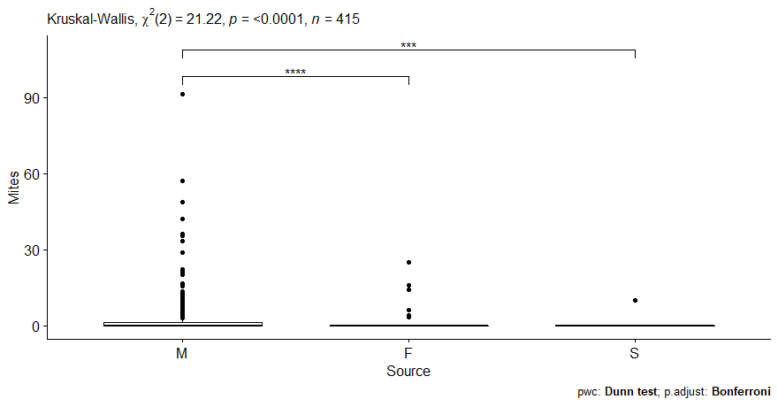

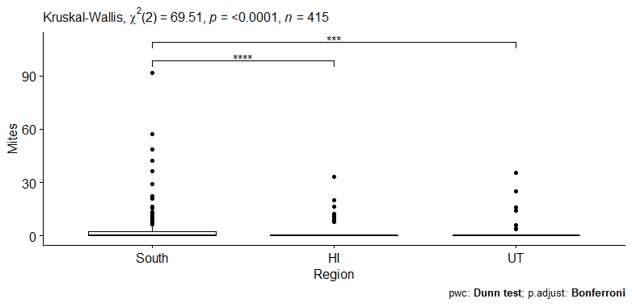

View(varroa)
library(tidyverse)
library(ggpubr)
library(rstatix)
set.seed(1234)
varroa %>% sample_n_by("Region", size=415)
varroa = varroa %>%
reorder_levels("Region", order = c("South", "HI", "UT"))

varroa %>%
group_by("Regions") %>%
get_summary_stats("Mites", type = "common")

ggboxplot(varroa, x="Region", y="Mites")

res.kruskal=kruskal_test(varroa, Mites~Region); res.kruskal
varroa %>% kruskal.test(Mites~Region)

varroa %>% kruskal_effsize(Mites~Region)
pwc= varroa %>% dunn_test(Mites~Region, p.adjust.method = "bonferroni");pwc
D2= varroa %>% wilcox_test(Mites~Region, p.adjust.method=("bonferroni"));D

pwc= pwc %>% add_xy_position(x="Region");pwc
ggboxplot(varroa, x="Region", y="Mites") +
stat_pvalue_manual(pwc, hide.ns= TRUE) +
labs(
subtitle = get_test_label(res.kruskal, detailed = TRUE),
caption = get_pwc_label(pwc)
)

set.seed(1234)
varroa %>% sample_n_by("Source", size=415)
varroa = varroa %>%
reorder_levels("Source", order = c("M", "F", "S"))

varroa %>%
group_by("Source") %>%
get_summary_stats("Mites", type = "common")

ggboxplot(varroa, x="Source", y="Mites")

res.kruskal=kruskal_test(varroa, Mites~Source); res.kruskal
varroa %>% kruskal.test(Mites~Source)

varroa %>% kruskal_effsize(Mites~Source)
pwc= varroa %>% dunn_test(Mites~Region, p.adjust.method = "bonferroni");pwc
D2= varroa %>% wilcox_test(Mites~Region, p.adjust.method=("bonferroni"));D

pwc= pwc %>% add_xy_position(x="Region");pwc
ggboxplot(varroa, x="Source", y="Mites") +
stat_pvalue_manual(pwc, hide.ns= TRUE) +
labs(
subtitle = get_test_label(res.kruskal, detailed = TRUE),
caption = get_pwc_label(pwc)
)

set.seed(1234)
varroa %>% sample_n_by("Lineage", size=415)
varroa = varroa %>%
reorder_levels("Lineage", order = c("A", "C", "M", "O"))

varroa %>%
group_by("Lineage") %>%
get_summary_stats("Mites", type = "common")

ggboxplot(varroa, x="Lineage", y="Mites")

res.kruskal=kruskal_test(varroa, Mites~Lineage); res.kruskal
varroa %>% kruskal.test(Mites~Lineage)

varroa %>% kruskal_effsize(Mites~Lineage)
pwc= varroa %>% dunn_test(Mites~Lineage, p.adjust.method = "bonferroni");pwc
D2= varroa %>% wilcox_test(Mites~Region, p.adjust.method=("bonferroni"));D

pwc= pwc %>% add_xy_position(x="Lineage");pwc
ggboxplot(varroa, x="Lineage", y="Mites") +
stat_pvalue_manual(pwc, hide.ns= TRUE) +
labs(
subtitle = get_test_label(res.kruskal, detailed = TRUE),
caption = get_pwc_label(pwc)
)

