1.
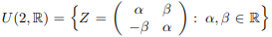
Lets be the group of real unitary matrices
- Prove, that U(2,R) is real linear space and find one of its bases.
- To study the matrices for linear dependence (independence)
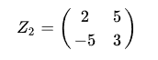
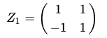
and

2. In the linear space regarding its standard basis are given the vectors:

3*1 = 4*e*2 + 7*e*3 + 3*e*4, 3*2 = (4 − 3, −3, 7 − 4, 4 − 3), 3*3 = (4 − 3, 4 − 3, 2*7 − 4, 4)

To study the matrices for linear dependence (independence) of the system of vectors
and to find Rank A.

